Overview
In this assignment we’ll look at basic CRUD operations in MongoDB. This assignment isn’t designed to give you a complete understanding of these topics, but is just meant to guide you through performing some basic database functions so that you can get a basic understanding of MongoDB

Recommended Readings

Review the following CRUD (CREATE, READ, UPDATE, DELETE) Documentation:
- Insert (Create): Insert Data into MongoDB
- Read: Read Data from MongoDB
- Update: Update Data in MongoDB
- Delete: Delete Data from MongoDB

Required Assignment

Briefly reflect on the following

What are some of the differences between MongoDB and SQL?
MongoDB is a NoSQL, document-oriented database that stores data in flexible, JSON-like documents (BSON). This allows for complex structures like the grades array in your example without needing a separate table.
SQL databases are relational, using fixed schemas and tables with rows and columns.

What are some differences in the client (Compass VS SQL Management studio)
MongoDB Compass is a GUI that allows for visual exploration of document structures and real-time schema analysis. It is a GUI that lets you "expand" nested objects and arrays visually.
SQL Management Studio (SSMS) is designed for relational data, focusing on table relationships, T-SQL scripting, and database administration. ) is built for relational data, primary keys, and tabular results.

Database Programming
Using your Restaurants collection, perform the following operations in the Compass MongoDB shell. Reminder: it can be opened by clicking this button:
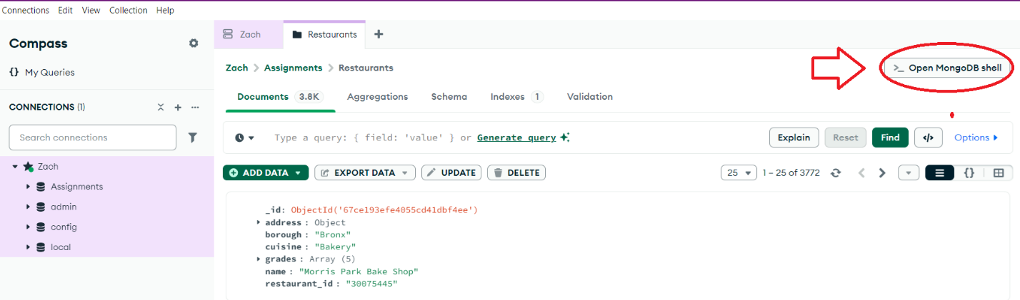
Result:

Basic CRUD Operations
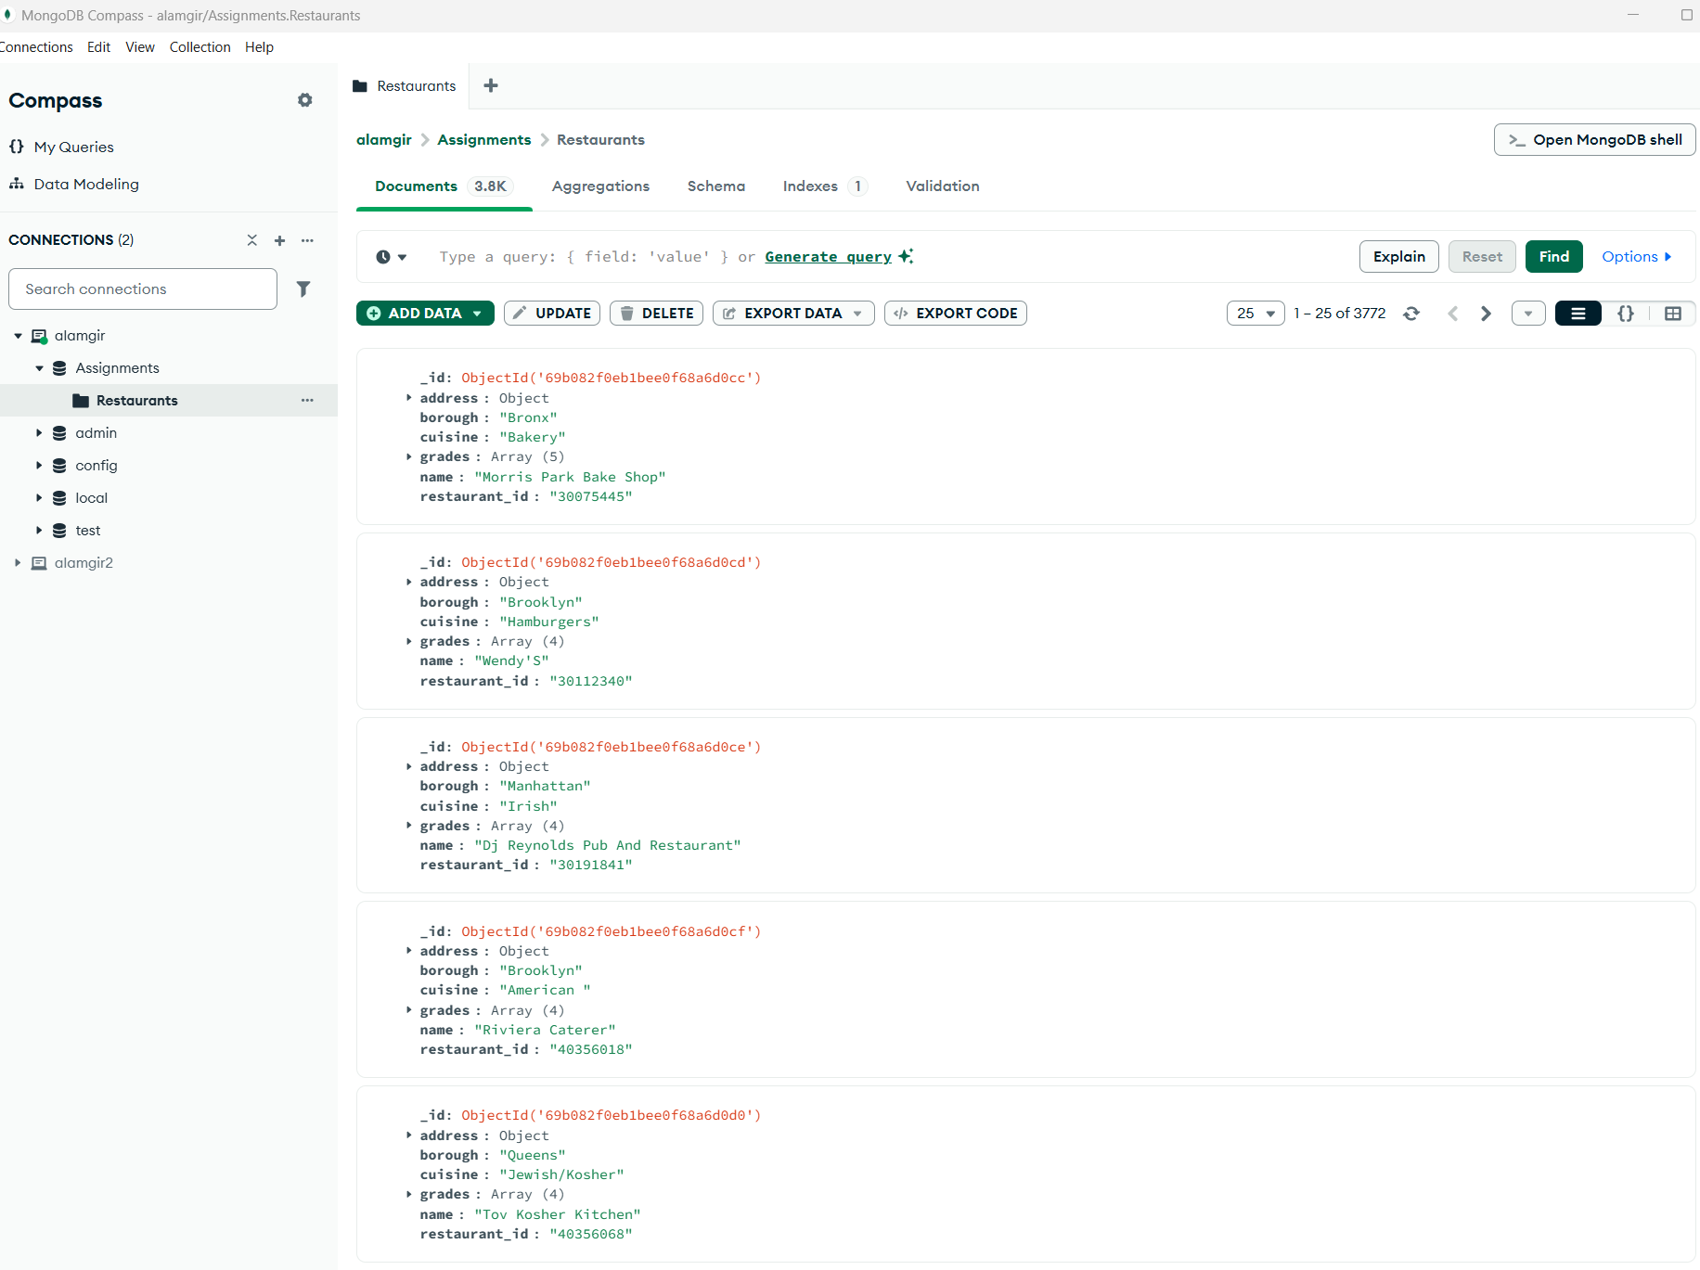

- Write a MongoDB query to display all the documents in the collection Restaurants
MongoDB query:
db.restaurants.find({})
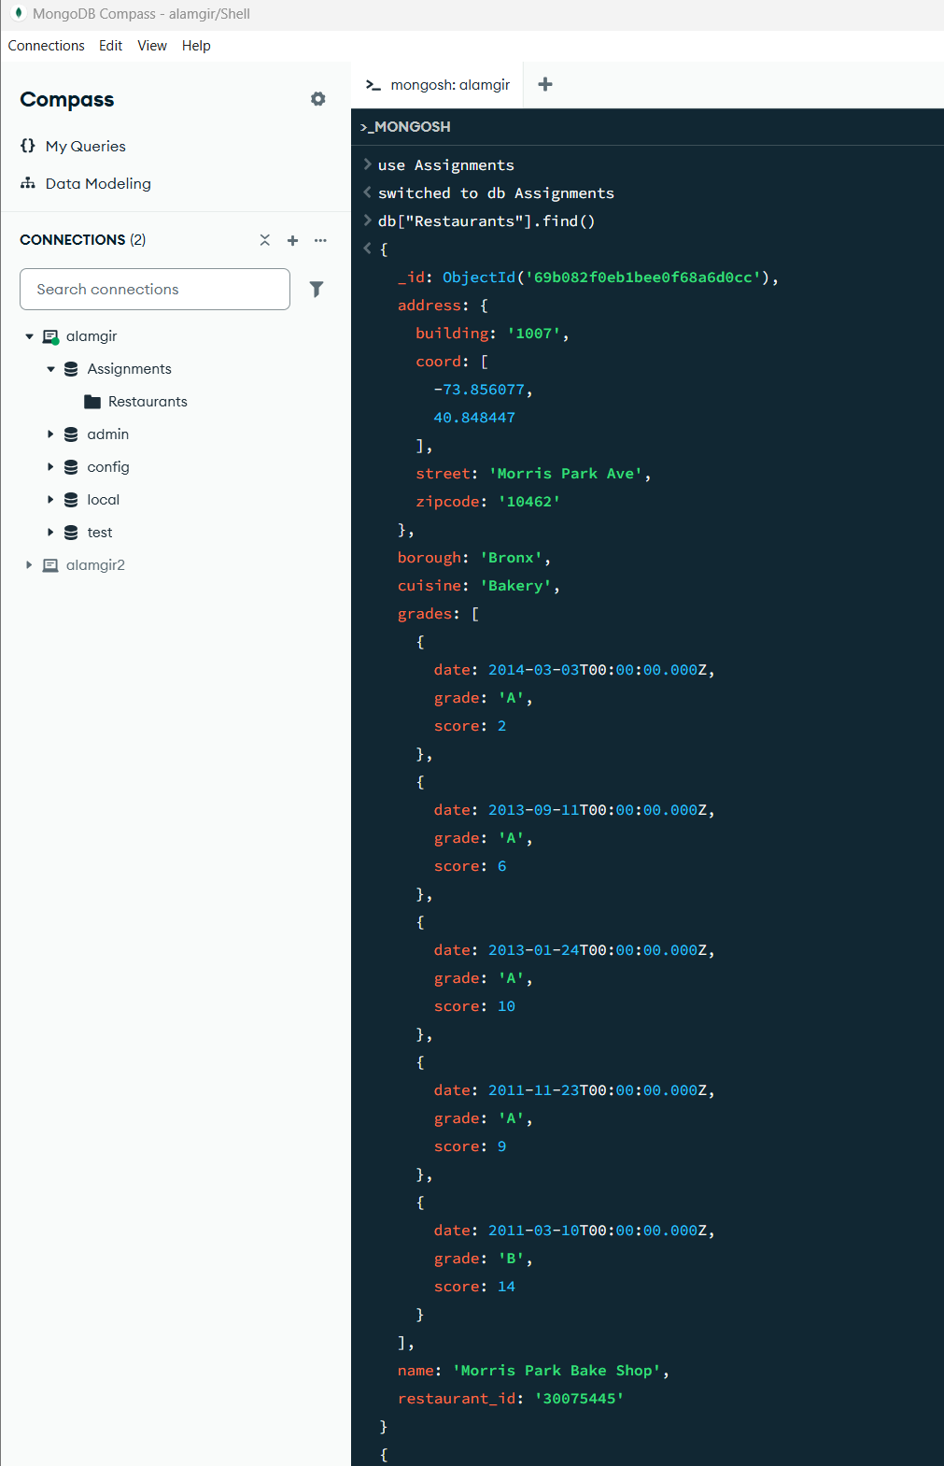
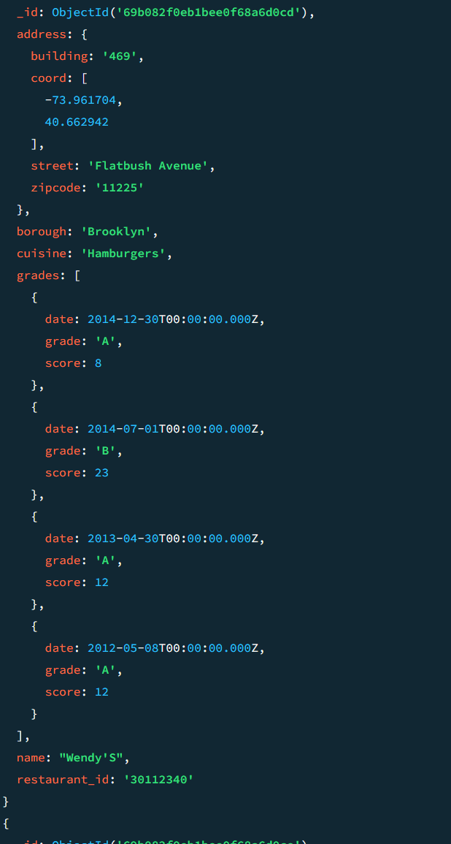
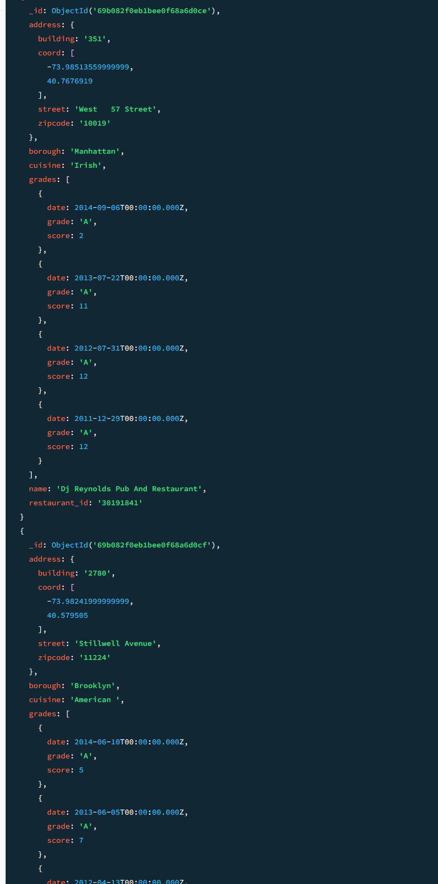
Continued----------
Explanation: The {} is an empty filter, telling MongoDB to return everything in the collection.
- Write a MongoDB query to display the fields restaurant_id, name, borough and cuisine for all the documents in the collection Restaurants
MongoDB query:
db.restaurants.find({}, { restaurant_id: 1, name: 1, borough: 1, cuisine: 1 })

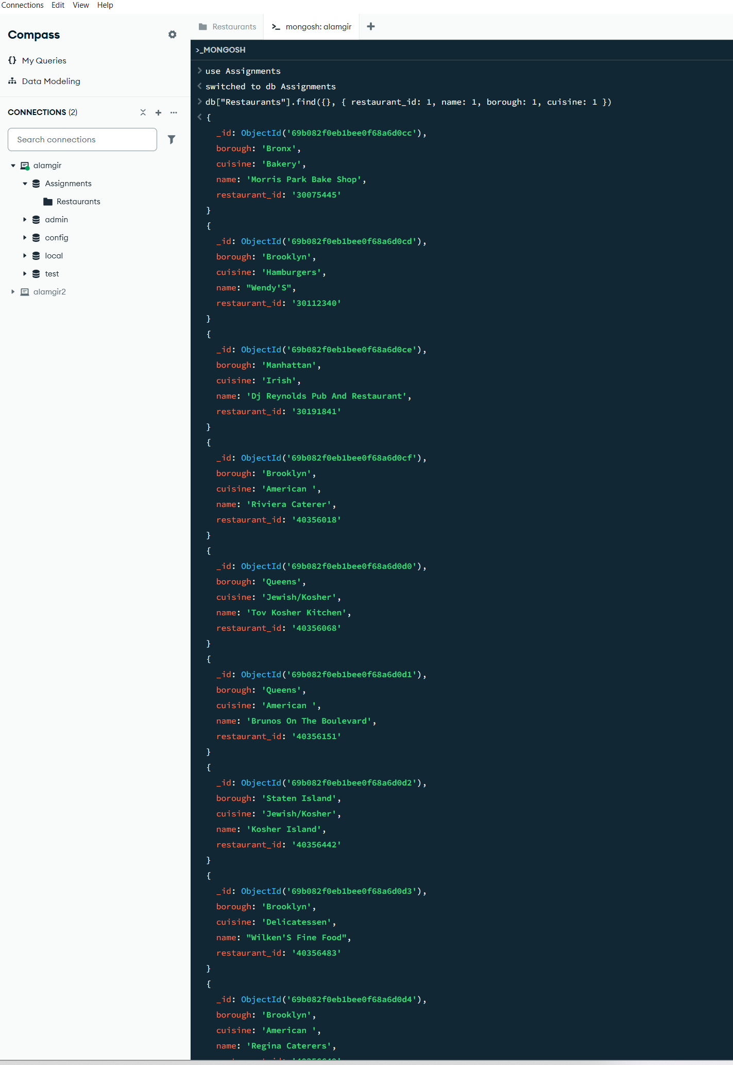
Explanation: The second object is the Projection. 1 means "include this field." Note that _id is included by default unless we set it to 0.

- Query for all restaurants with a restaurant_id of 40383009
MongoDB query:
db.Restaurants.find({ restaurant_id: "40383009" })
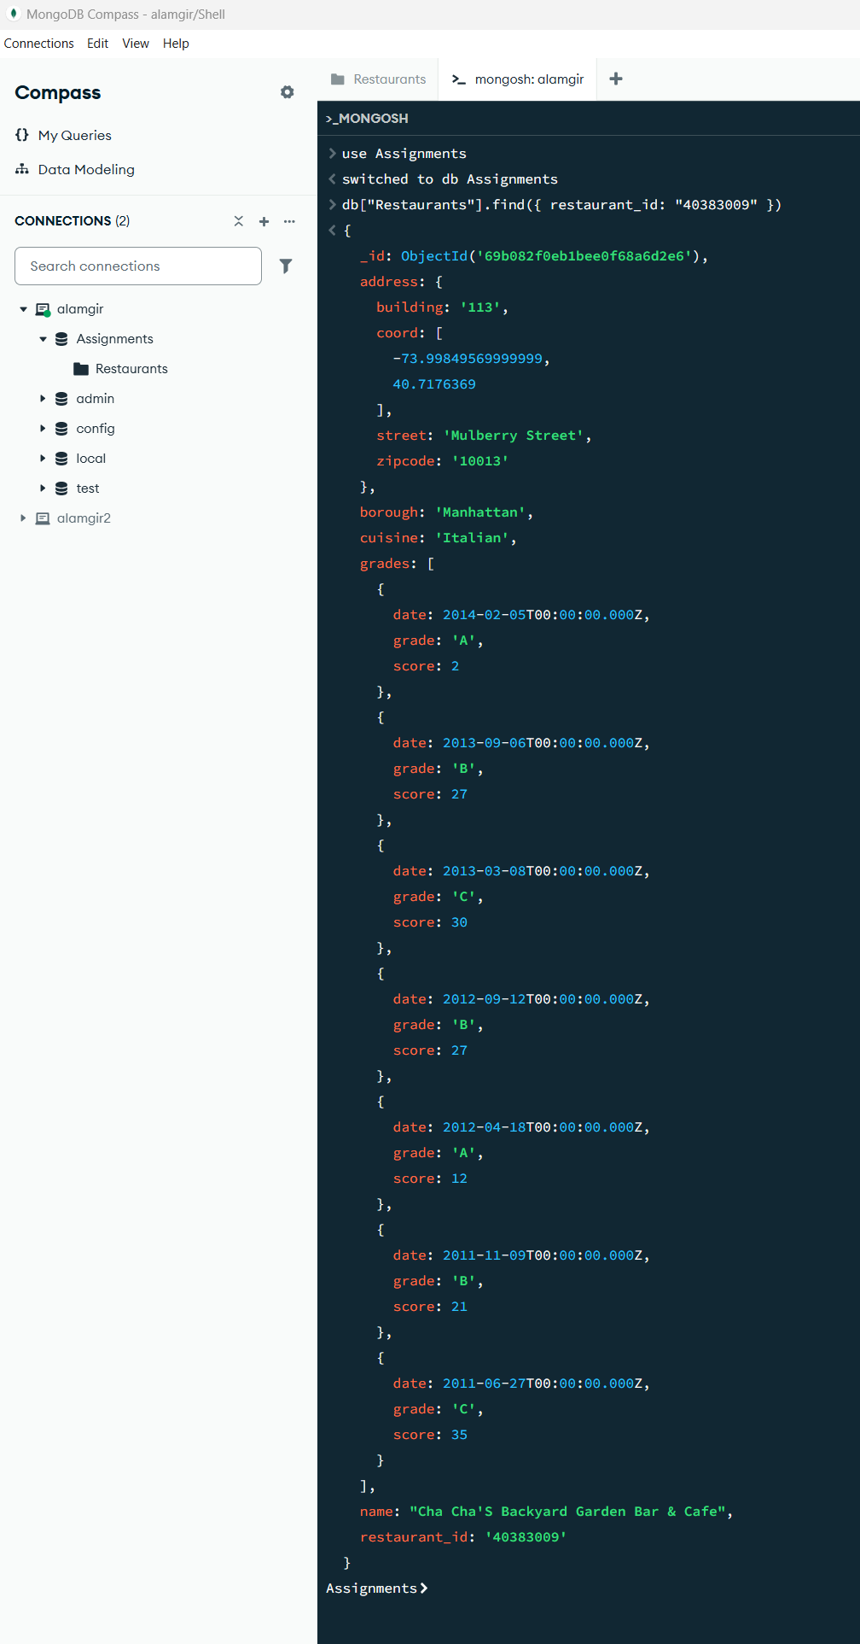
- Insert a new restaurant with the following information
Restaurant
borough | cuisine | name | Restaurant_id | address | grades
Westchester | Italian | Like Mama Used to Make | 41565445 | See below | Null

Address
building | Coord 0 | Coord 1 | street | zipcode
210 | 45.665898 | 13.4455 | 7th Ave | 95944
MongoDB query:
db.Restaurants.insertOne({ borough: "Westchester", cuisine: "Italian", name: "Like Mama Used to Make", restaurant_id: "41565445", address: { building: "210", coord: [45.665898, 13.4455], street: "7th Ave", zipcode: "95944" }, grades: null })

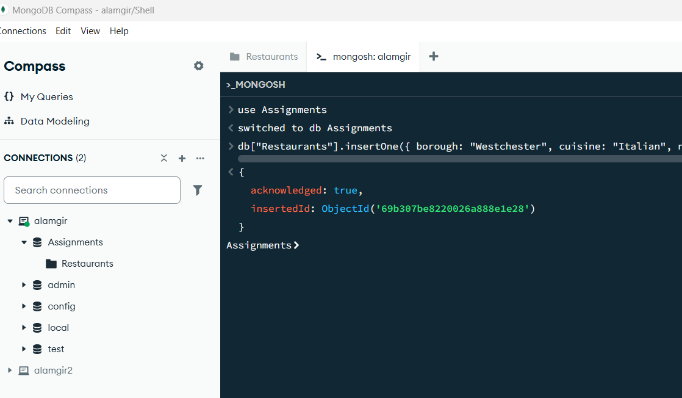

- Update your new restaurant to change the Coord 1 to 14.4455
MongoDB query:
db.Restaurants.updateOne( { restaurant_id: "41565445" }, { $set: { "address.coord.1": 14.4455 } } )
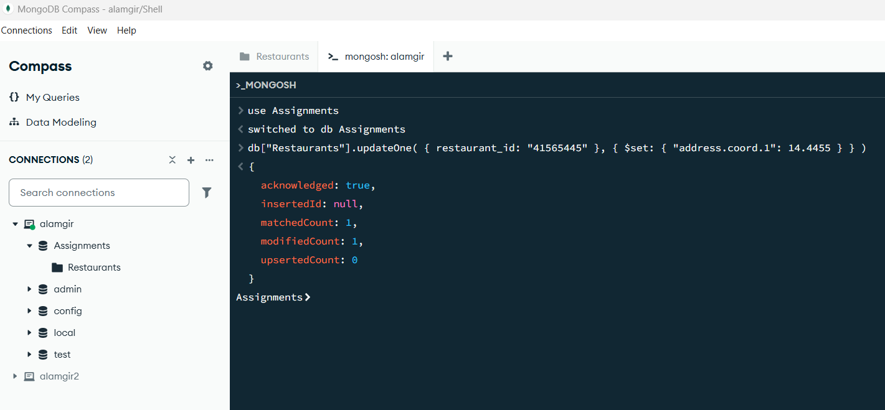
- Delete your new restaurant
MongoDB query:
db.Restaurants.deleteOne({ restaurant_id: "41565445" })
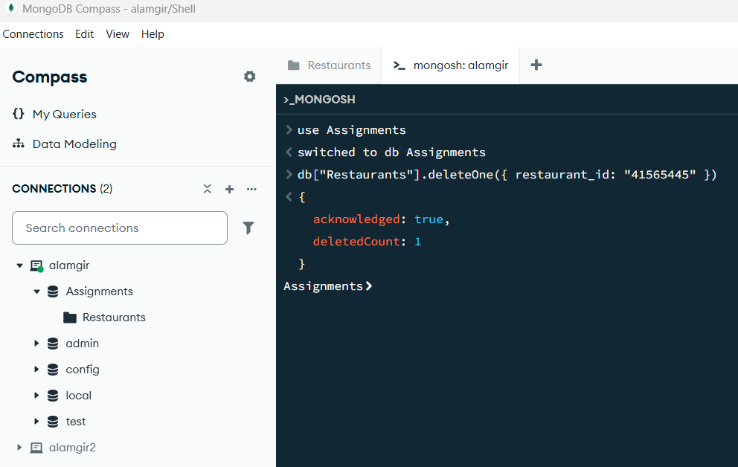

Selected terms
Do some research (or use notes from class) to complete the following table by providing a brief description in your own words of the command listed. Use these commands to answer the following MongoDB questions
Term | Description
.find() | The primary method to select documents from a collection
.limit() | Specifies the maximum number of documents the cursor will return
.skip() | Tells MongoDB to start returning results after a certain number of documents
$elemMatch | Matches documents that contain an array field with at least one element matching all criteria
$lt | Less Than.
$gt | Greater Than
$and | Joins query clauses with a logical AND; returns documents that match all conditions
$ne | Not Equal
.sort() | Specifies the order in which the query returns matching documents

More MongoDB Queries

- Write a MongoDB query to display the fields restaurant_id, name, borough and zip code, but exclude the field _id for all the documents in the collection Restaurants that serve American cuisine
db.Restaurants.find({ cuisine: "American" }, { _id: 0, restaurant_id: 1, name: 1, borough: 1, "address.zipcode": 1 })
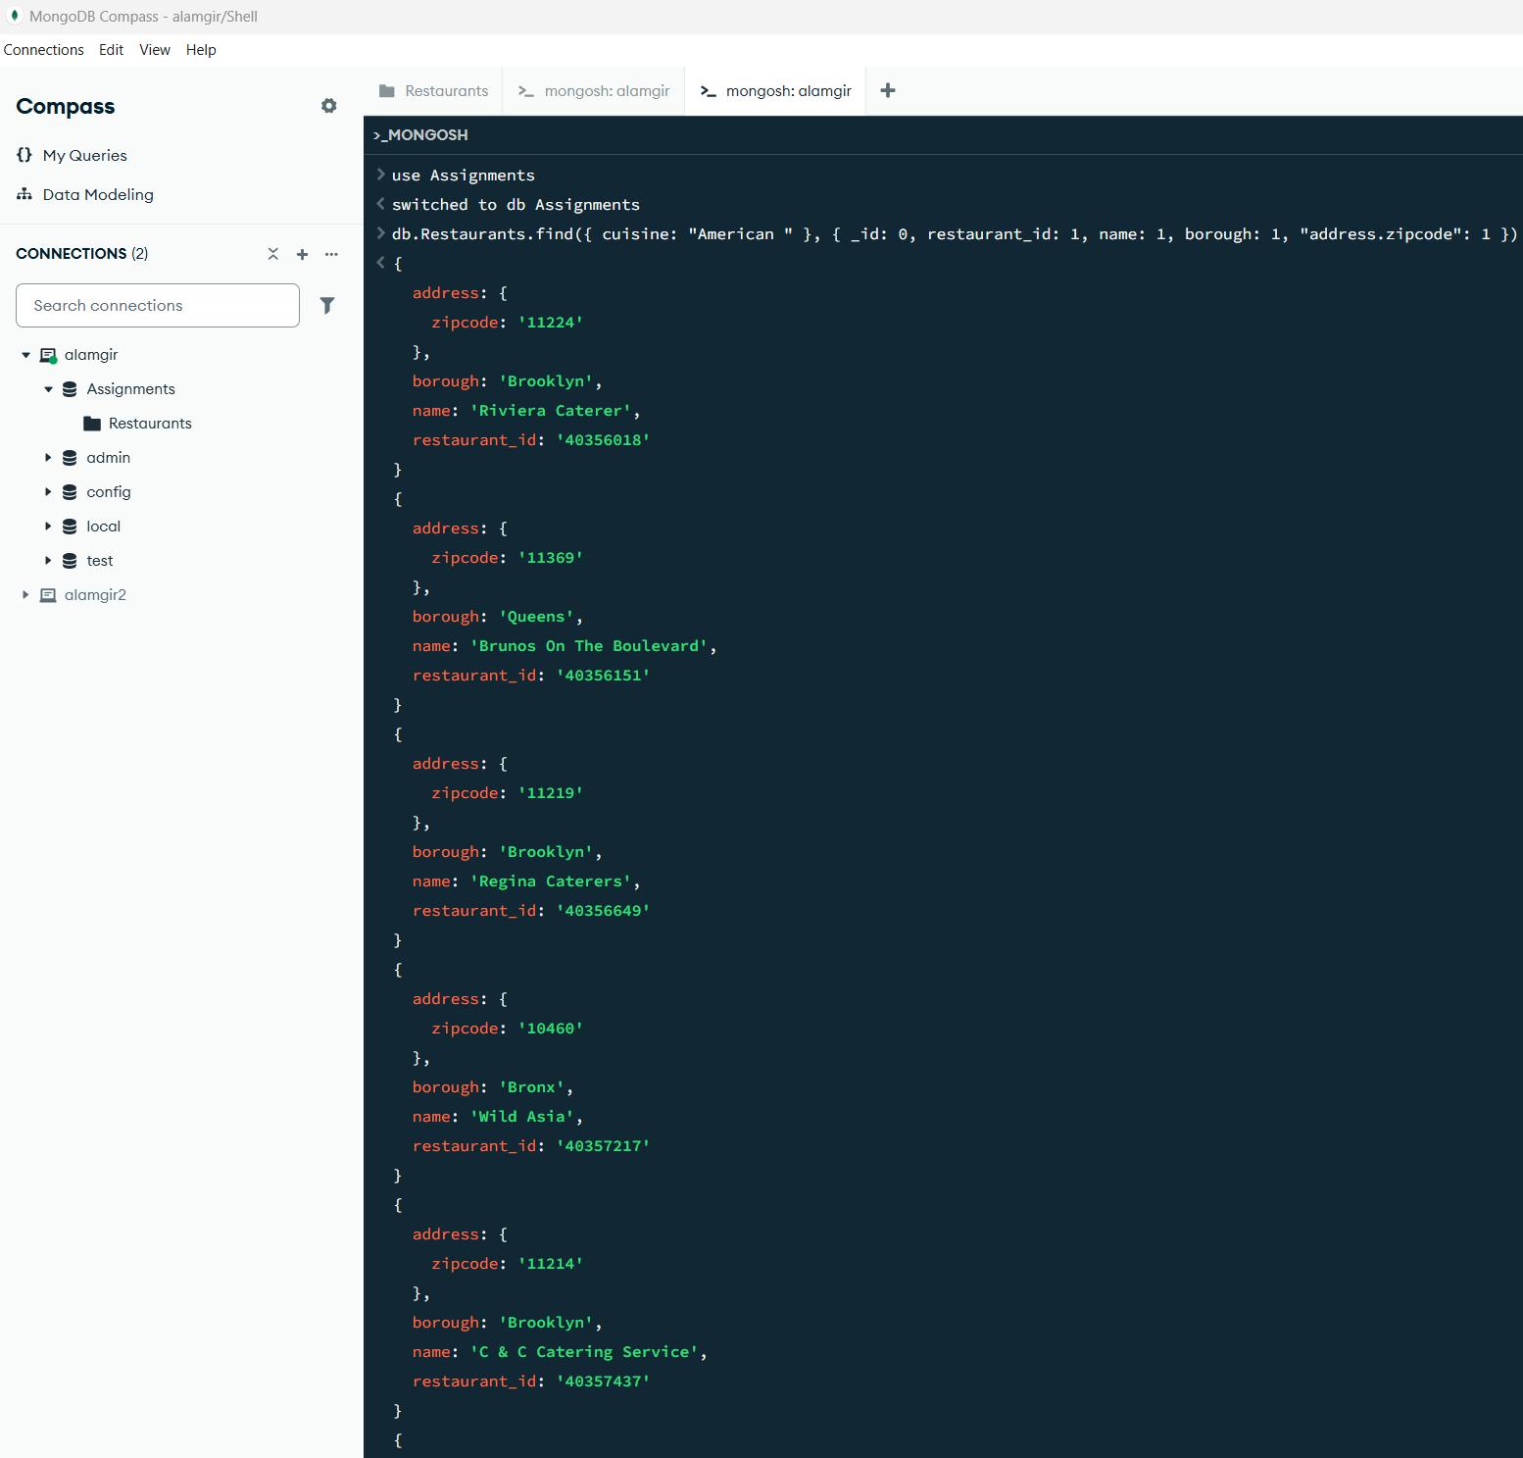

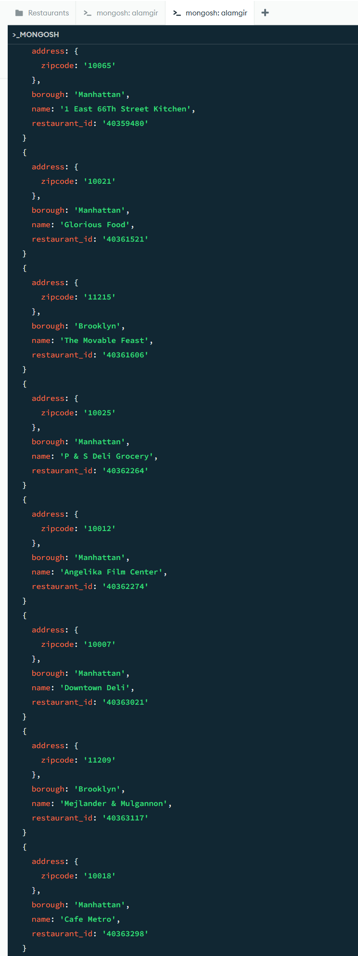
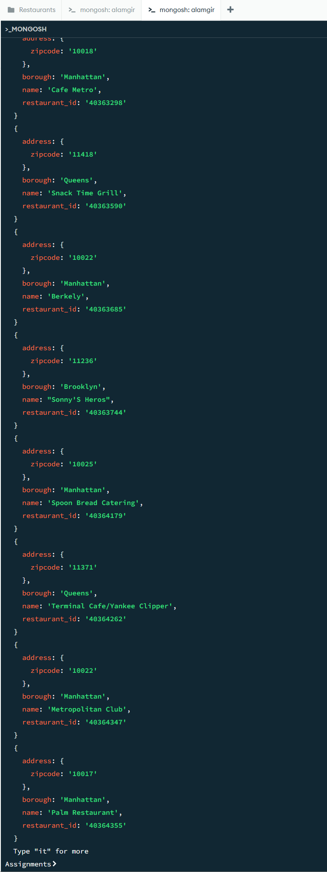

- Write a MongoDB query to display all the Restaurants which are in the borough Manhattan
db.Restaurants.find({ borough: "Manhattan" })
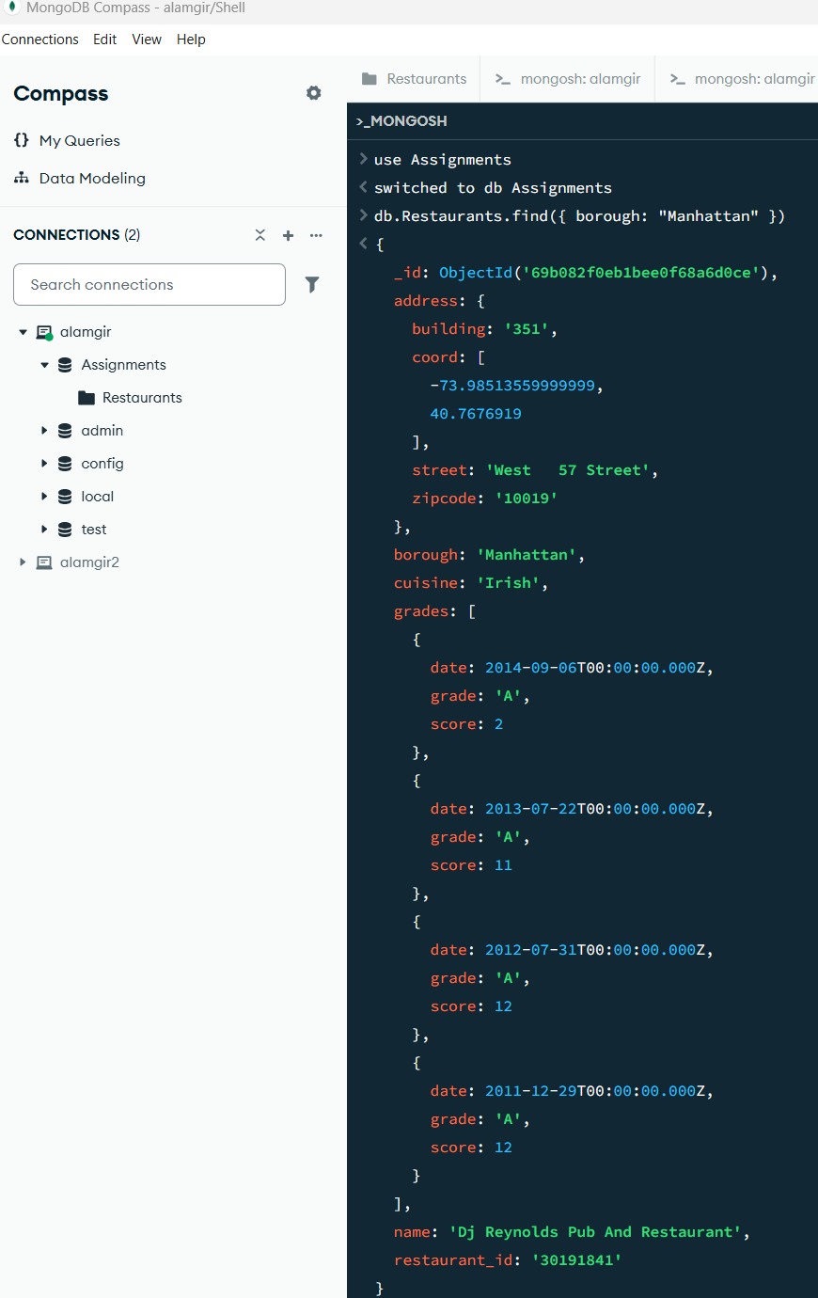

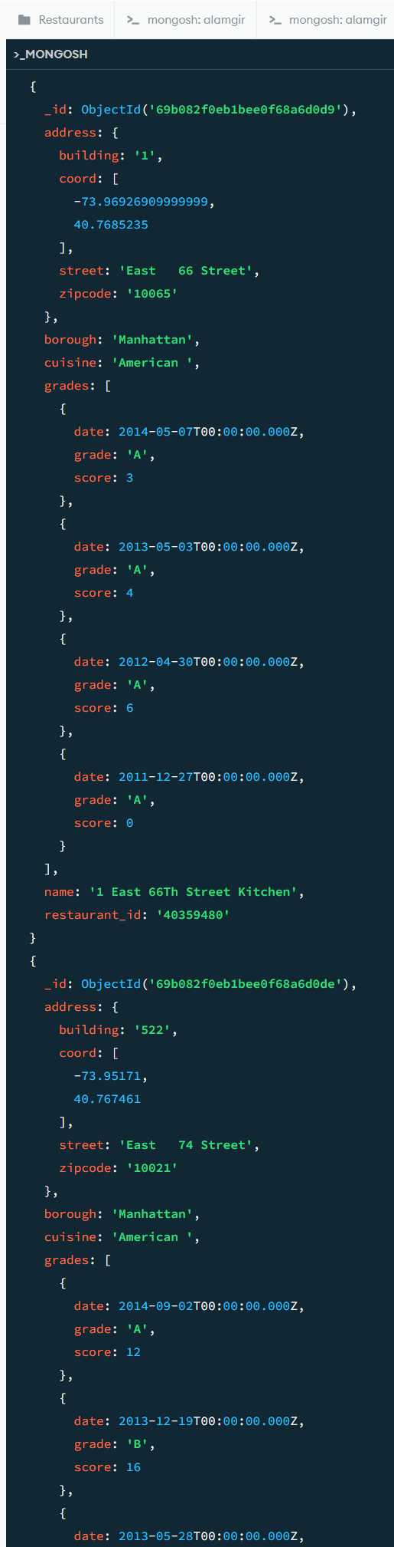
And more continued…………………..

- Write a MongoDB query to display the first 5 Restaurants which are in the borough Bronx
db.Restaurants.find({ borough: "Bronx" }).limit(5)
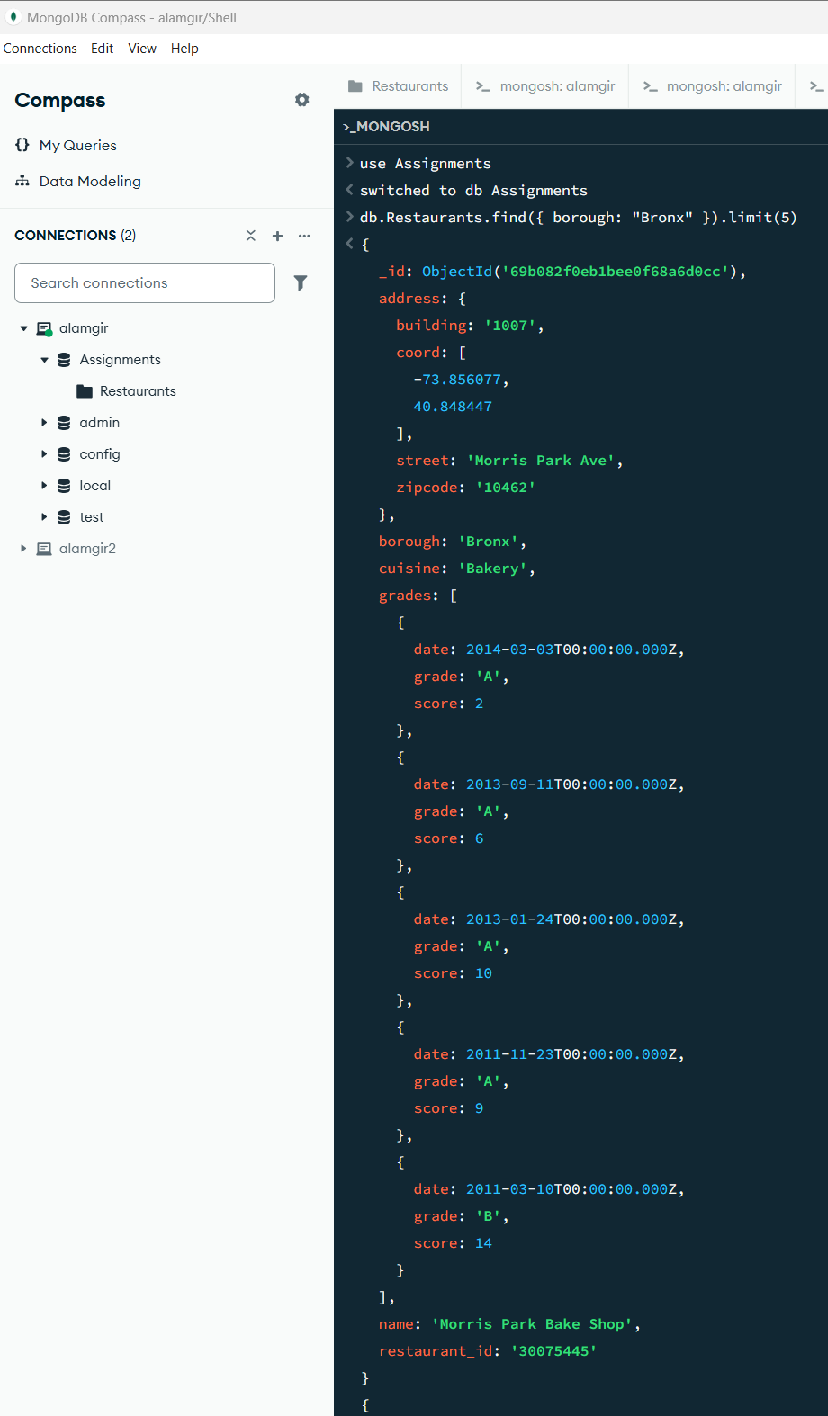
Continued….
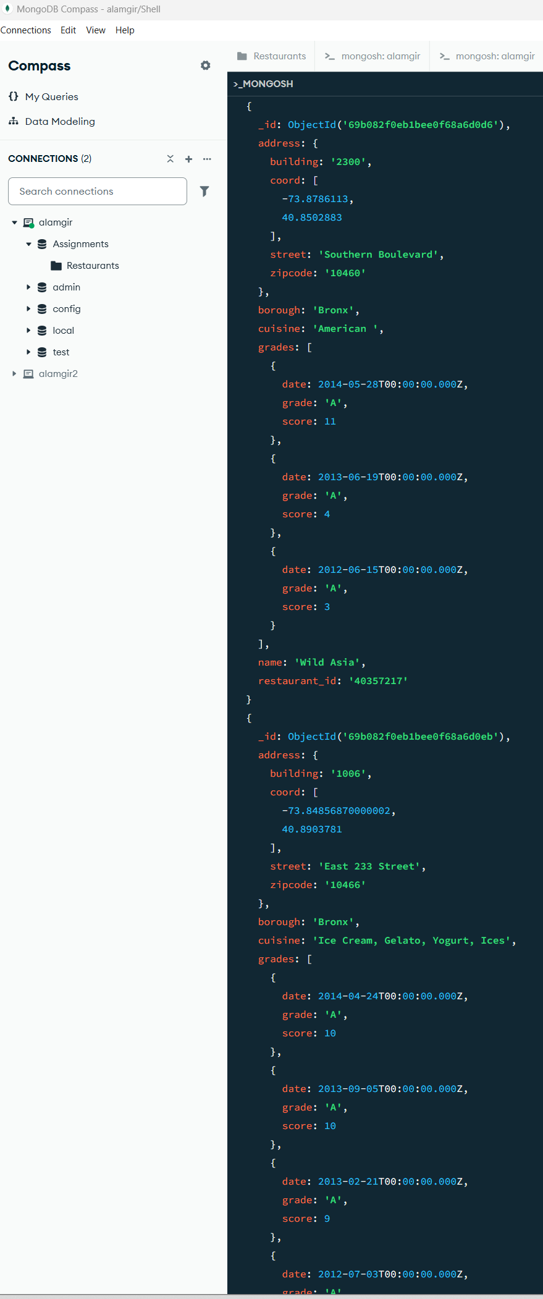
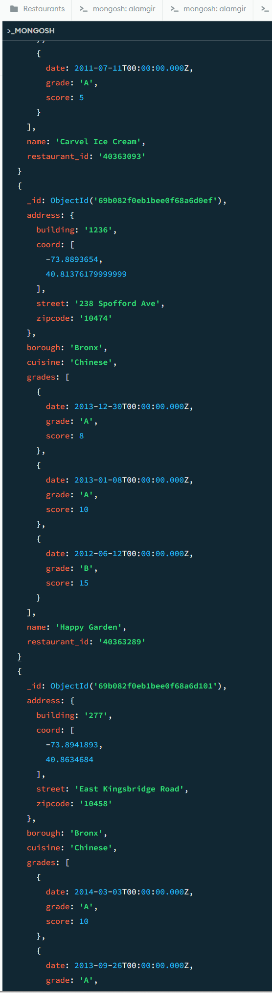
And more…. Upto five records.
- Write a MongoDB query to display the next 5 Restaurants after skipping first 5 which are in the borough Bronx
db.Restaurants.find({ borough: "Bronx" }).skip(5).limit(5)
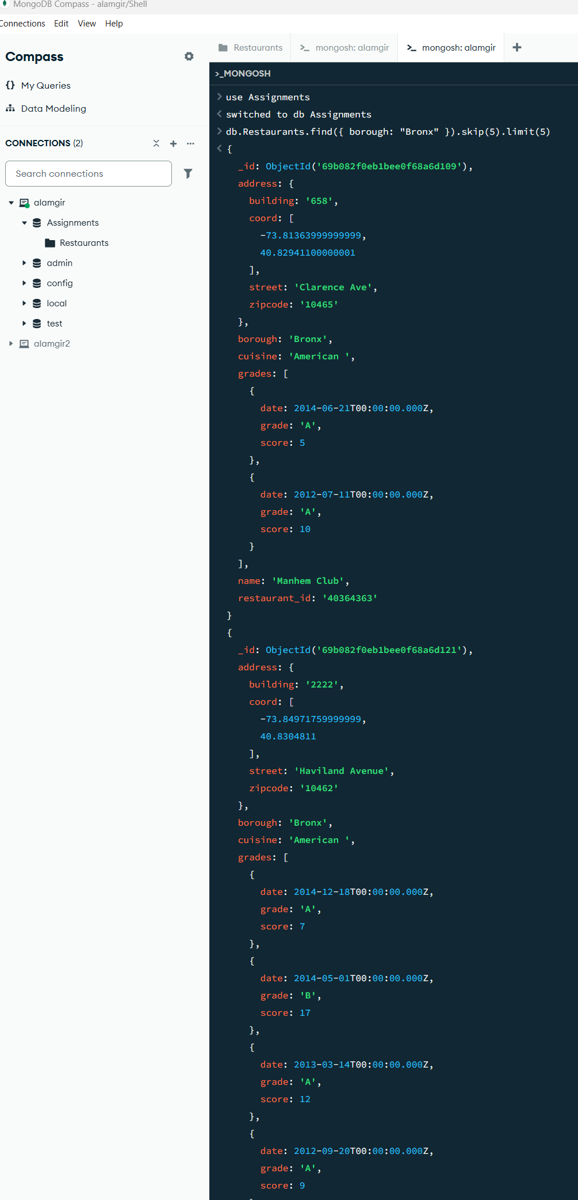
Note: It displayed 5 record by skipping first 5 records.
- Write a MongoDB query to find the Restaurants who achieved a score more than 90
db.Restaurants.find({ "grades.score": { $gt: 90 } })
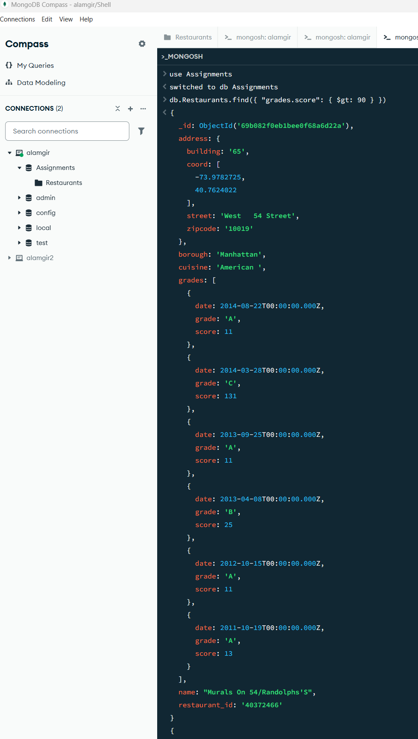
This query looks inside the grades array. It found at least one entry where the score was greater than 90 (the second grade in that document has a score of 131).

- Write a MongoDB query to find the Restaurants that achieved a score more than 80 but less than 100
db.Restaurants.find({ "grades.score": { $gt: 80, $lt: 100 } })
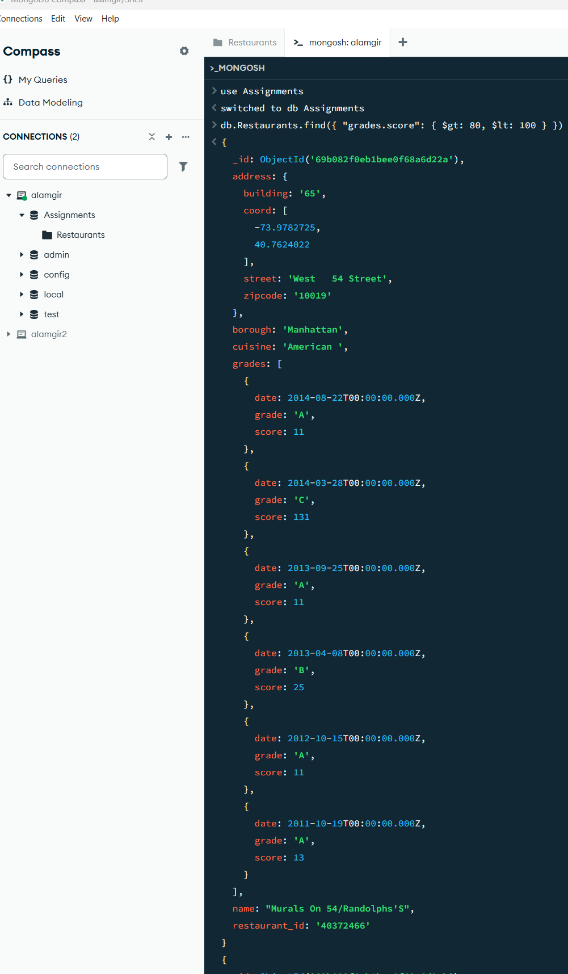
Notes: The query looks for a document where at least one score in the grades array is between 81 and 99.

- Write a MongoDB query to find the Restaurants which locate in latitude value less than -95.754168
db.Restaurants.find({ "address.coord.0": { $lt: -95.754168 } })
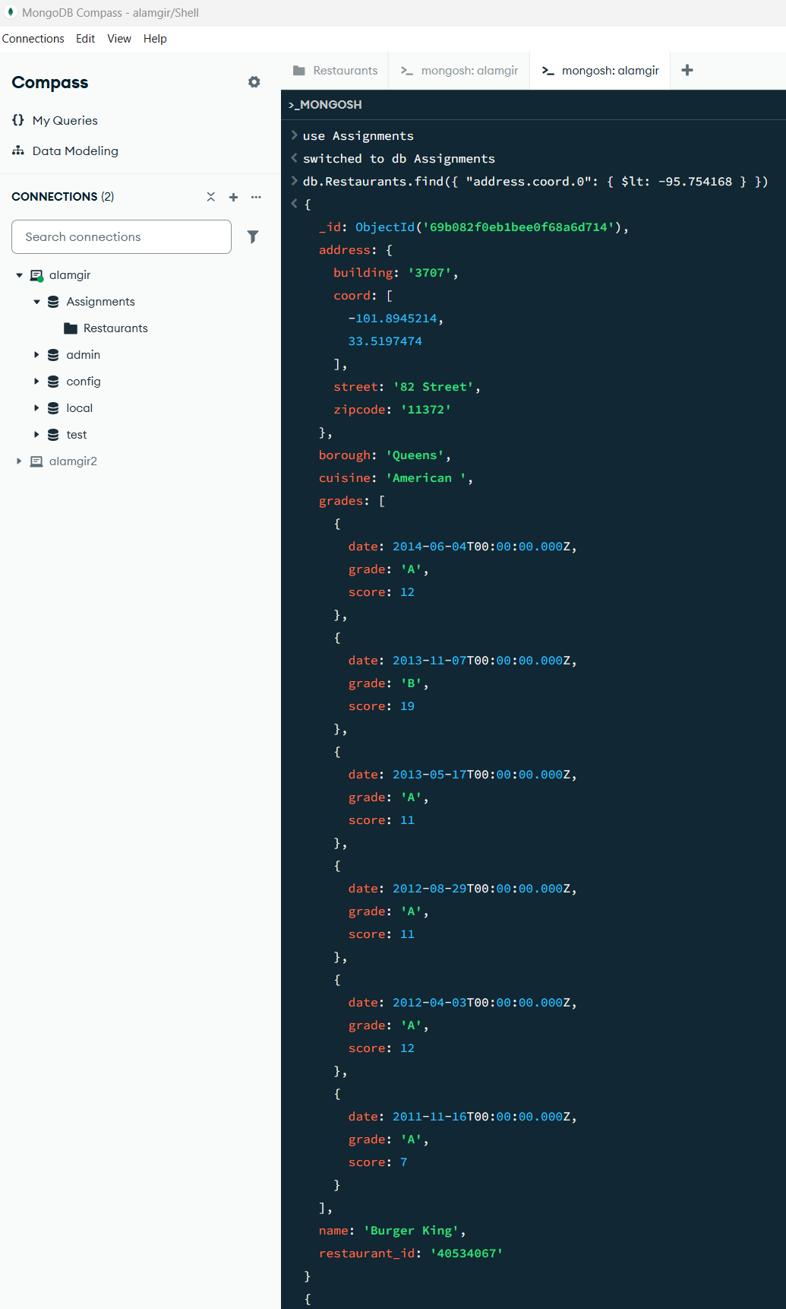
Note: This query searches the Restaurants collection for documents where the longitude (the first value in the coord array) is less than -95.754168.

- Write a MongoDB query to display the names and cuisine of Restaurants in the borough Staten Island in alphabetical order by restaurant name

db.Restaurants.find({ borough: "Staten Island" }, { name: 1, cuisine: 1 }).sort({ name: 1 })
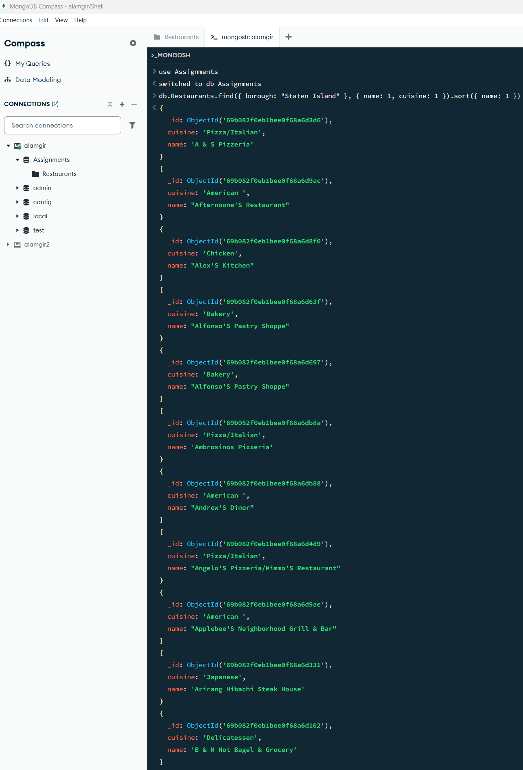
This query retrieves all restaurants located in the borough of Staten Island, displaying only their names and cuisine types, and sorts the results in alphabetical order by the restaurant name

- Write a MongoDB query to find the Restaurants that do not prepare any cuisine of 'American' and their grade score more than 70 and latitude less than -65.754168
db.Restaurants.find({ cuisine: { $ne: "American" }, "grades.score": { $gt: 70 }, "address.coord.0": { $lt: -65.754168 } })
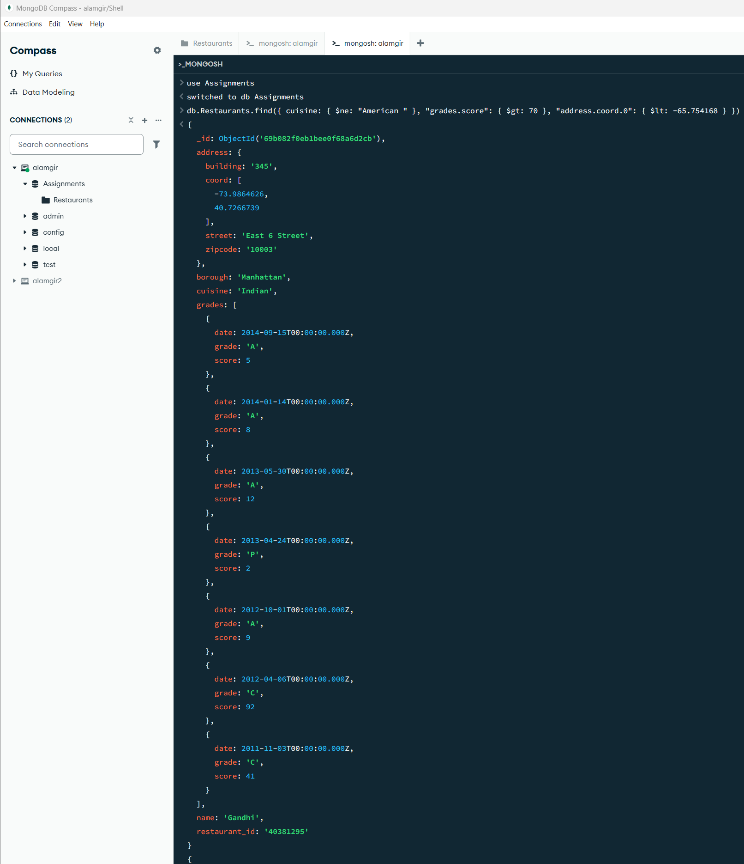
Note: This query identifies restaurants that meet three specific conditions: 1. cuisine: { $ne: "American" }: It excludes any restaurant that serves "American " cuisine 2. ("grades.score": { $gt: 70 }: It looks for restaurants that have at least one grade with a score greater than 70. 3. "address.coord.0": { $lt: -65.754168 }: It filters for restaurants where the longitude (the first value in the coordinate array) is less than -65.754168.
- Write a MongoDB query to find the Restaurants which prepare cuisine of ‘Asian’ and achieved a score more than 70 or located in the borough Queens.
  - Note: Do this query without using $and operator
db.Restaurants.find({ cuisine: "Asian", or: [ { "grades.score": { gt: 70 } }, { borough: "Queens" } ] })
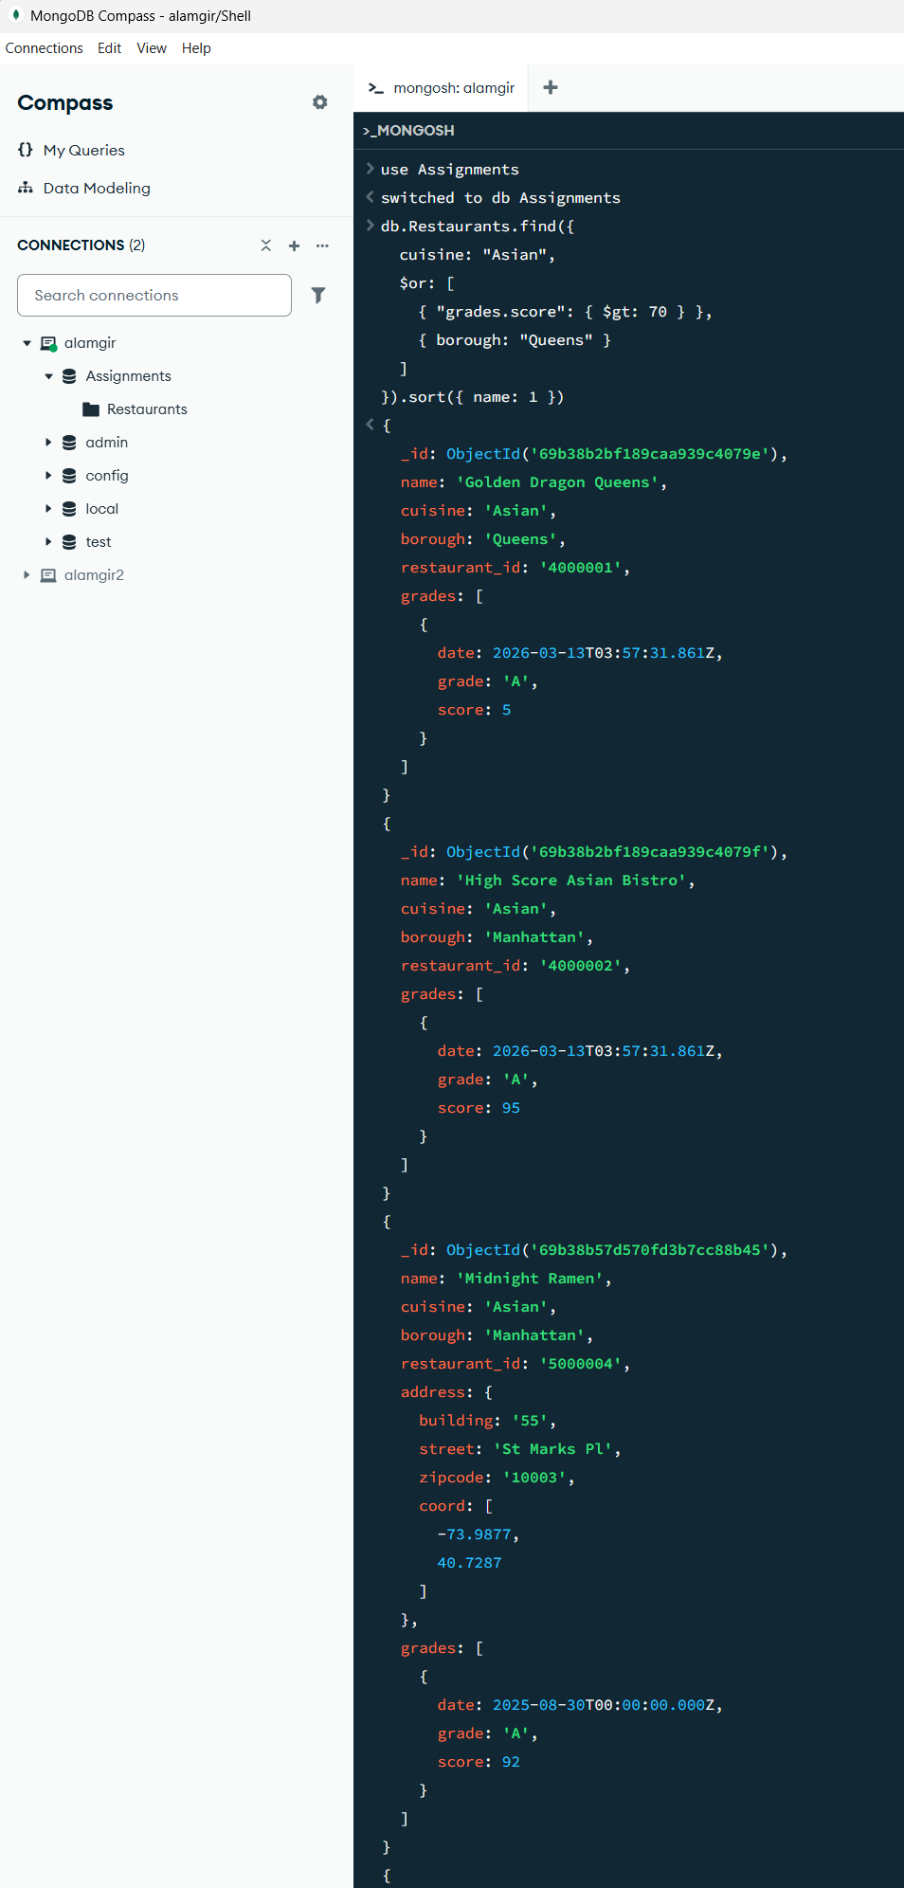
The query execution performs the following logic: 01. It first filters for all documents where the cuisine is exactly "Asian". 2. Logical OR ($or): Within those Asian restaurants, it checks for at least one of two conditions: The restaurant is located in the borough of "Queens". The restaurant has at least one inspection score greater than 70. Implicit AND: Because the cuisine filter is placed outside the $or array, MongoDB implicitly joins it with an AND operation. This means a restaurant must be "Asian" AND meet one of the two conditions in the bracket to be returned in the results.
To verify the query logic, I manually inserted several test records with the "Asian" cuisine type into the collection. This was necessary because the original dataset uses specific regional categories (such as Chinese or Thai) rather than the general "Asian" descriptor. By inserting these records, I ensured there was valid data to demonstrate that the query performs as expected.

